Year 5 | Addition and Subtraction
- Children use columns in written addition and subtraction, accurately adding and subtracting numbers with more than four digits.
- They use mental methods to add and subtract increasingly large numbers, and use rounding to check their answers.
- They choose the appropriate operation, the most efficient methods and work out the level of accuracy required to answer a particular problem.
Addition | Using counters and the written method  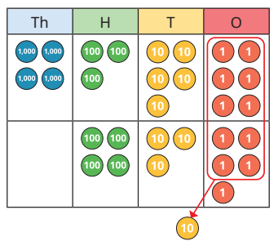  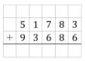  1 4 5 4 6 9  In year 5 the children begin to add numbers with more than four digits. The process is still the same as previous years and we always start in the ones column.  In Year 5, some of the children will continue to use counters to support their understanding of column addition. In this example, the numbers 4356 and 435 have been made using counters. Next, addition has begun in the ones column. Here an exchange needs to happen as 6 + 5 totals to 11.

Mental Strategies
Children explore strategies such as compensation and adjustment to mentally calculate the answer to questions such as 14,352 + 999 or 14,352 – 999. This helps them to make connections between calculations which will be developed further in Year 6.
See the example below
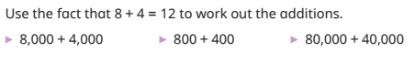
Children recap and build on their learning from previous years to mentally calculate sums and differences using partitioning. They use their knowledge of number bonds and place value to add multiples of powers of 10. Children use related facts to help them complete a calculation.
For example, if they know that 3 + 5 = 8, then 3 thousand + 5 thousand = 8 thousand and 3,000 + 5,000 = 8,000

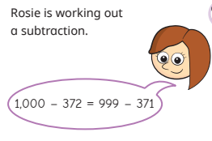

Subtraction | Counters and column subtraction  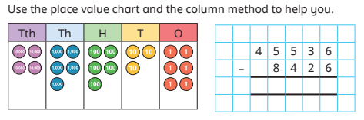  In this example, children make 45536 using counters. Starting from the ones column:  6-6 = 0  30 – 20 = 10  500-400 = 100  When they get to the thousands column, the children need to exchange 1 ten thousand for 10 thousands.  15000 – 8000 = 7000  As we have used exchange, it is no longer 40000 and is now 30000.  Our answer is:  37110.

Year 5 | Multiplication and Division
- Multiply numbers up to 4 digits by a one- or two-digit number using a formal written method, including long multiplication for two-digit numbers.
- Multiply and divide numbers mentally, drawing upon known facts.
- Divide numbers up to 4 digits by a one-digit number using the formal written method of short division and interpret remainders appropriately for the context.

Multiplication |  | Counters  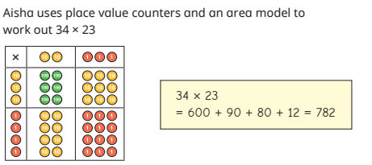  Children use the area model to multiply a 2-digit number by another 2-digit number before moving on to the formal written method in the next step. Linking the use of the area model to children’s prior knowledge of arrays helps children to understand the model. They see that to find the total product, they can break the calculation down, find other products and then add them together.  Short multiplication method  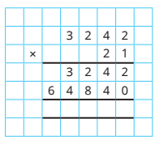  Children start from the ones column.  3242 x 1 = 3242  3242 x 20 = 64840  Then add both products to total = 68082  Long multiplication method Grid method  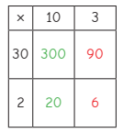  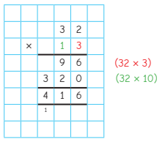  The grid method is a way of multiplying two numbers with more than one digit.  We can partition 13 into 10 + 3  We can partition 32 into 30 + 2  Write the partitioned parts of each number outside the rows and columns of the grid.  Multiply the two numbers that are outside in each box and write the answer in each box.  Add up the products in boxes to calculate the final answer.  Children start from the ones column and multiply:  3 x 2 = 6  3 x 30 = 90  = 96  Then children move to the tens column and multiply:  10 x 2 = 20  10 x 30 = 300  = 320  Add both products together = 416  As the children move through the place value columns, they write the number sentences in brackets (32 x 3) and (32 x 10).
Division | 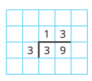  Counters Short Division  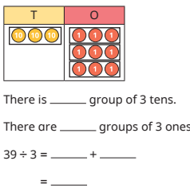  The dividend (number being divided) is placed inside the ‘bus stop’ and the divisor (number the dividend is being divided by) is placed to the left of the ‘bus stop’. The answer (quotient) is placed above.  3 goes into 30 = 10 times so you place a 10 ten the tens column.  3 goes into 9 = 3 times so you place a 3 in the ones column.  Children partition 39 into 3 tens and 9 ones. Then they group them into 3 equal groups.  There is 1 group of 3 tens.  There are 3 groups of 3 ones.  39 divide by 3 = 10 + 3  = 13  Counters (with exchange) Short division (with exchange)  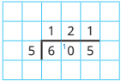  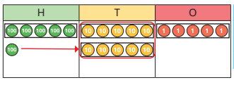  605 divided by 5  In the example above, you have to exchange one hundred for ten counters.  Short division (with remainders)  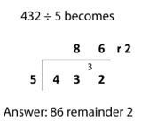  In this calculation, the 5 will not ‘go into’ the 4. So you need to look at the first two digits. There are eight 5s in 43 (8 x 5 = 40), so an 8 is written on the top line. The remaining 3 is carried to the next digit. 32 is then divided by 5 and the answer 6 is written above. The remaining 2 can either be written as a remainder, the fraction 2/5 or decimal 0.4, depending on the context.

