Year 6 | Addition, Subtraction, Multiplication and Division
- solve addition and subtraction multi-step problems in contexts, deciding which operations and methods to use and why.
- solve problems involving addition, subtraction, multiplication and division.
- multiply multi-digit numbers up to 4 digits by a two-digit whole number using the formal written method of long multiplication.
- divide numbers up to 4 digits by a two-digit number using the formal written method of short division where appropriate, interpreting remainders according to the context.

Addition  Subtraction | 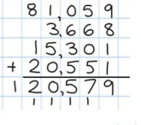  Column Addition  Remember to insert place holders.  As in previous years, the children will continue to use column addition to add several numbers of increasing complexity including decimals with different numbers of decimal points.  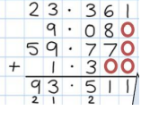  Column Subtraction  Continuing on from previous years, the children will continue to use column subtraction to subtract with increasingly large and more complex numbers and decimal values.  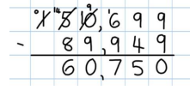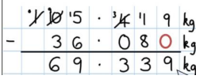

Multiplying numbers up to 2 decimal places by a single digit.
Remind children that the single digit belongs in the ones column. Line up the decimal points in the question and the answer.
In this case it is important to have a firm grasp of estimation and place value.
Multiplication  Division | 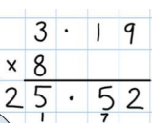  18 x 3 on the first row (8 x 3 =24, exchanging the 2 for 20, then 1 x 3) 18 x 10 on the 2nd row. Show multiplying by 10 by putting zero as a place holder in units first.  Short Multiplication  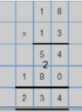  Expanded Long Multiplication Long Multiplication Method  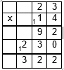  In this method, the amount of recording is reduced further. When the multiplication is carried out it is important to record clearly the carrying of tens. It is also crucial to recognise in the recording of the multiplication that the digit 1 in 14 represents 10 and not 1 unit. Hence, we obtain 230 and not 23 as our second product.  In this method, it is important to remember the place value of each digit in the numbers being multiplied e.g. the 1 in 14 represents 10 not 1 unit. The four products are recorded and added together to provide the final answer.  In this calculation, the 15 will not ‘go into’ the 4. So, you need to look at the first two digits. There are 2 lots of 15 in 43 (2 x 15 = 30), so 2 is written on the top line. The 30 is then written below, and subtracted from, the 43 to give a remainder of 13. The next digit in the dividend is then ‘brought down’. You must now divide 132 by 15, which gives a result of 8. This 8 is written above and the 120 (15 x 8) is subtracted from 132. The remaining 12 is smaller than 15, so the answer could be expressed as 28 r12 or 2812/15. Alternatively, as the example shows, a decimal point is written both in the answer and the dividend. A zero is then ‘brought down’. 120 is divided by 15 to give 8, which is written above, after the decimal point. 120 (15 x 8) is subtracted from 120 to give 0, showing that the calculation is complete.  Long Division  To solve this, divide 98 by 7 one digit at a time, starting from the left with the 9. Put the result of each division on the top line. As there is one 7 in 9 (or in fact ten 7s in 90), a 1 is placed on the top; the remaining 2 is carried over to the following digit in the number. 28 is now divided by 7 to give an answer of 4.  Short Division  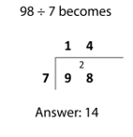  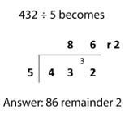  In this calculation, the 5 will not ‘go into’ the 4. So you need to look at the first two digits. There are eight 5s in 43 (8 x 5 = 40), so an 8 is written on the top line. The remaining 3 is carried to the next digit. 32 is then divided by 5 and the answer 6 is written above. The remaining 2 can either be written as a remainder, the fraction 2/5 or decimal 0.4, depending on the context.
   |  | 2 | 3
  x |  | 1 | 4
   |  | 1 | 2
   |  | 8 | 0
   |  | 3 | 0
  1 | 2 | 0 | 0
   | 3 | 2 | 2

