Year 4 | Addition and Subtraction
- Children extend previous years’ work by adding and subtracting numbers with up to four digits, using mental and written methods, including columnar addition and subtraction.
- They keep practising mental methods of addition and subtraction as well as written methods, performing calculations increasingly quickly and confidently. They continue using estimation as well as inverse operations to help check answers.
- Add and subtract numbers with up to 4 digits using the formal written methods of columnar addition and subtraction where appropriate.
- Estimate and use inverse operations to check answers to a calculation.
- Solve addition and subtraction two-step problems in contexts, deciding which operations and methods to use and why.
Addition | Adding two 4-digit numbers (no exchange)  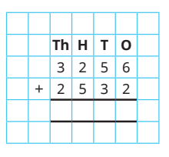  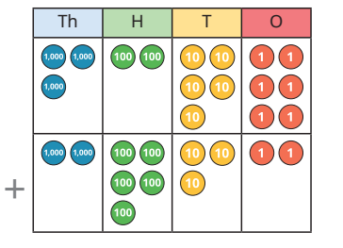  The numbers being added together may have a different number of digits, so children need to take care to line up the digits correctly. Even though there will be no exchanging, the children should be encouraged to begin adding from the ones column.  5 7 8 8
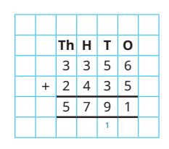
Adding 2 4-digit numbers (one exchange)
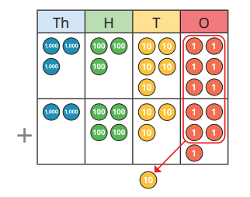

The numbers being added together may have a different number of digits, so children need to take care to line up the digits correctly. An exchange will occur here because there are two numbers (6 and 5) when added together are greater than 10. You must exchange ten ones for one ten – don’t forget to add your exchange!

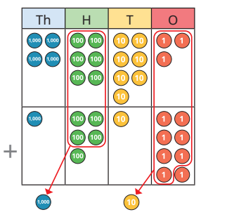
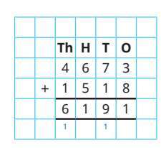
Adding 2 4-digit numbers (more than one exchange)

Subtraction | 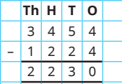  Subtract 2 4-digit numbers (no exchange)  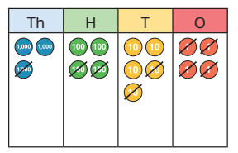  Children subtract up to a 4-digit number from a 4-digit number with no exchanges, using concrete resources as well as the formal written method. Even though there is no exchanging, children should subtract from the smallest value column first. Before subtracting each column, ask, “Do you have enough ones/tens/hundreds to subtract ? ” If not, an exchange is needed.  Subtract 2 4-digit numbers (one exchange)  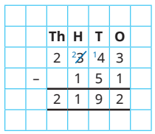  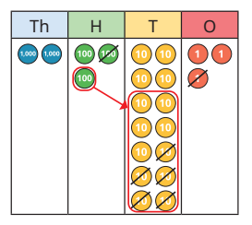  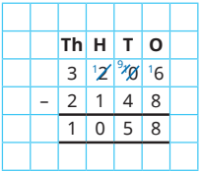  Subtract 2 4-digit numbers (more than one exchange)  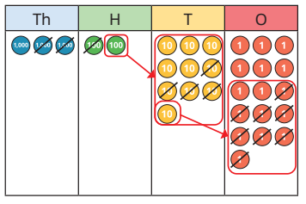  Children start from the smallest column (the ones). Build 3206 using counters and then cross out 2148. If the number at the top is smaller than the number at the bottom, you will need to exchange!  Children perform subtractions involving two separate exchanges (for example, from the thousands and from the tens) as well as those with two-part exchanges (for example, from the thousands down to the tens if there are no hundreds in the first number).  Number lines  3000 – 1345 =  +5 +50 +600 +1000  Children count up to the nearest 10, 100 and 1000 in order to work out the difference. Then add all the amounts to calculate the answer (5+50+600+1000).  1345 1350 1400 2000 3000

Year 4 | Multiplication and Division
- recall multiplication and division facts for multiplication tables up to 12 × 12
- use place value, known and derived facts to multiply and divide mentally, including: multiplying by 0 and 1; dividing by 1; multiplying together 3 numbers
- recognise and use factor pairs and commutativity in mental calculations
- multiply two-digit and three-digit numbers by a one-digit number using formal written layout
- solve problems involving multiplying and adding, including using the distributive law to multiply two-digit numbers by 1 digit, integer scaling problems and harder correspondence problems such as n objects are connected to m objects

Multiplication | 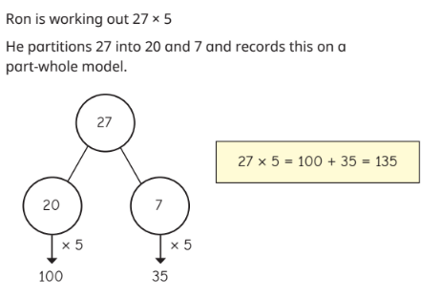  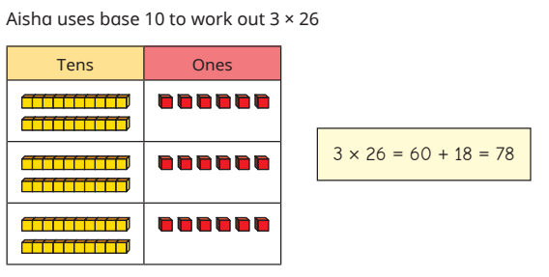  Informal Written Methods  The use of base 10 encourages children to partition the tens and ones laying the foundations for later work. Part-whole models are used to illustrate the informal method of partitioning. Children use number lines, along with their knowledge of multiplying by 10. For example, to work out 26× 8 they count along a number line to show 10 × 8 + 10 × 8 + 6 x 8  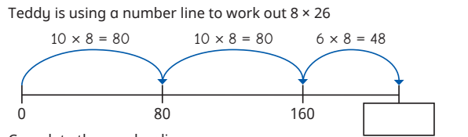  Multiply a 2-digit number by a 1-digit number (expanded form)  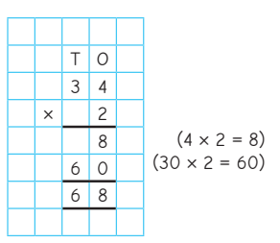  Children start in the ones column and multiply 4 x 2 = 8. Then they move to the tens column and multiply 30 x 2 = 60. Children then add both numbers together 8 + 60 = 68.  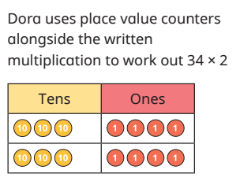  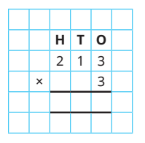  Multiply a 3-digit number by a 1-digit number (short method)  Children start in the ones column 3 x3 = 9. The 9 is written underneath the ones column. Next, the children move to the tens column 10 x 3 = 30. The children write a 3 in the tens column. Then they multiply 200 by 3 = 600 and write a 6 underneath the hundreds column.  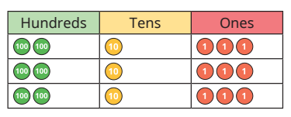  6 3 9

Division | Divide a 2-digit number by a 1-digit number (counters to part-whole model).  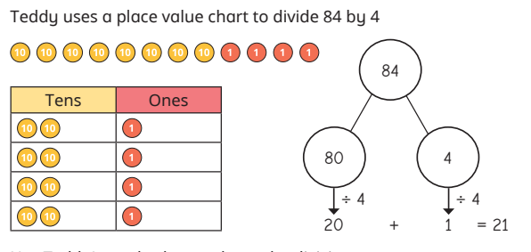  Place value counters are used to explore the sharing structure of division. Children do not need to use the formal short division method at this stage.  Children equally share their 10s and 1s into their columns. The children then total each row.  Children then move onto the part whole model. The children partition 84 into 80 and 4. Next the children divide 80 by 4 = 20 and 4 divide by 4 = 1. Then you add the two numbers together = 21.  Divide a 2-digit number by a 1-digit number with remainders (counters)  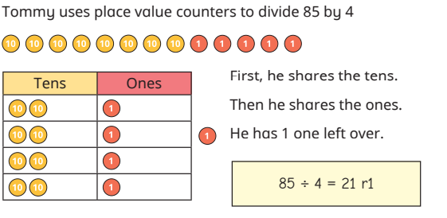  Divide a 3-digit number by a 1-digit number (counters)  Place value counters are again used to represent the calculations, so that children can make sense of exchanges that are needed to complete the division.  Part-whole models are also used to show how flexible partitioning can support the process of division by looking for multiples of the number being divided by.  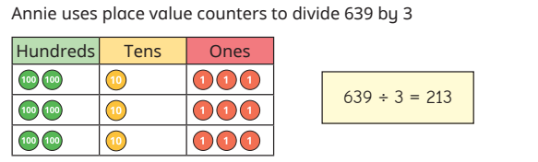  Divide a 3-digit number by a 1-digit number (Part whole model)  

