Year 3 | Addition and Subtraction
- Add and subtract numbers mentally, including:
- a three-digit number and 1s
- a three-digit number and 10s
- a three-digit number and 100s
- add and subtract numbers with up to 3 digits, using formal written methods of columnar addition and subtraction
- estimate the answer to a calculation and use inverse operations to check answers
- solve problems, including missing number problems, using number facts, place value, and more complex addition and subtraction

Addition | Number lines Adding 10s to a 3-digit number  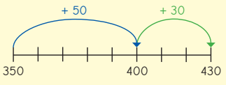  Adding 1s to a 3-digit number  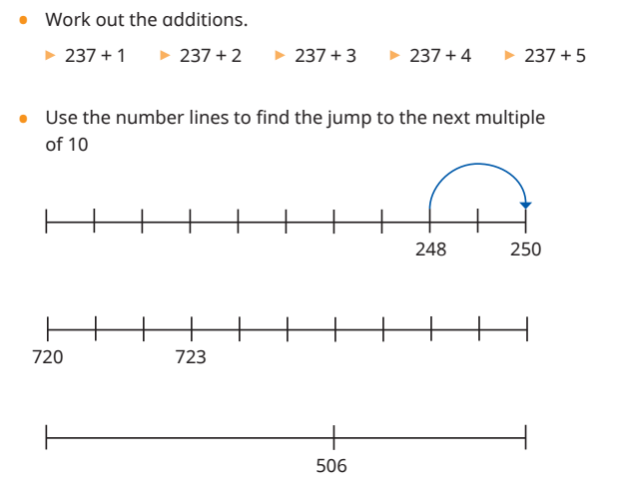  Children need to be fluent in their bonds within 100, for example 80 = 50 + 30, to allow them to efficiently and flexibly partition numbers to work out how much further they need to jump after reaching the next 100  Base10  Children build both 3- digit numbers. Children then add their numbers starting from the ones column.  8 + 3 = 11  The children must therefore exchange 10 ones for one 10.  Remember to add the exchange!  Adding two numbers without crossing 10 Adding two numbers crossing 10  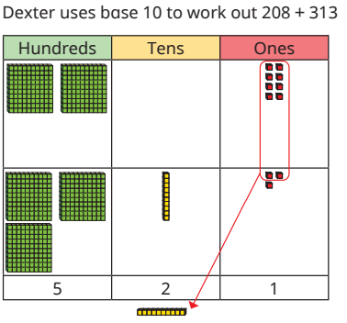  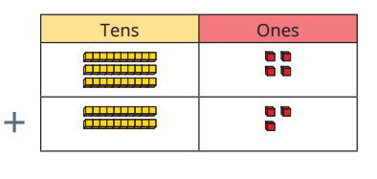  34 + 23 =  Children build both numbers using dienes and then add the dienes starting from the ones column

Adding two numbers crossing 100 Counters
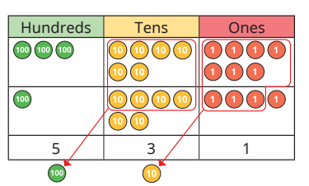
466 + 353 =
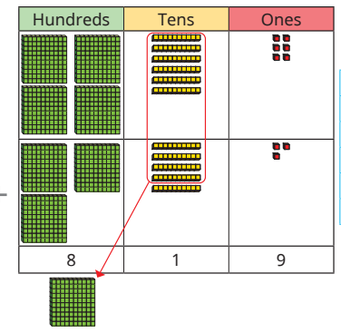
Children build both numbers using dienes and then add the dienes starting from the ones column. 60 + 50 = 110 so the children have to exchange 10 tens for 1 one hundred.
Adding two numbers crossing 10 and 100.

Column addition (written method)

Adding two 2-digit numbers (no exchange) Adding two 3-digit numbers (no exchange)
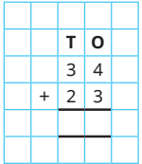
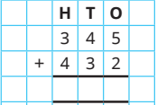
Building on from concrete and pictorial resources, children should feel confident to place their digits in the correct place value columns.
Children start from the ones column and use their number bonds to 10 to calculate the answer.
7 7 7
5 7

Adding two 3-digit numbers (exchange)
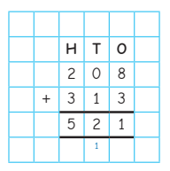
Start from the ones. Remember to add your exchange.

Subtraction | Children should continue to use horizontal number line – encourage use of visualisation of lines and grids. Children should also be encouraged to look at the difference between two numbers before making a decision about how to use the number line e.g. small or large difference – count on or count back. Children should be taught subtraction alongside addition. Decomposition should only be introduced when children are secure with informal jottings and number lines.  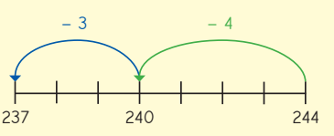  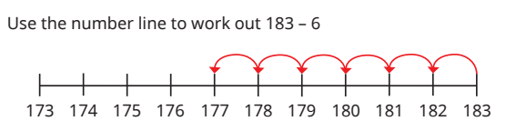  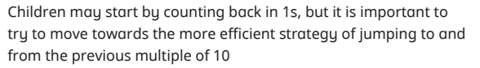  Number lines  Dienes Counters  Subtract two 2-digit numbers (no exchange) Subtract two 3-digit numbers (no exchange)  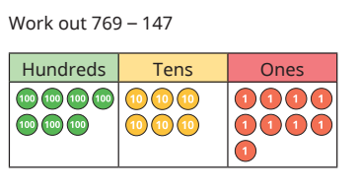  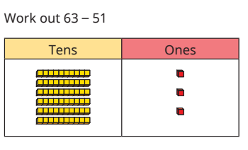  Using counters, you need to build your greatest number and then you need to cross our a hundred, 4 tens and 7 ones (147).  The remaining counters are 622.  Using dienes, you need to build the greater number (63) and then you need to cross out 5 tens and 1 one (51).  Written method  No exchange With exchange  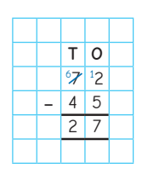  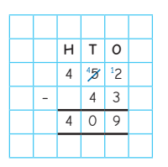  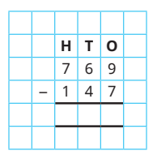  If the top number is smaller than the bottom number – you need to exchange from the next column.  Here I have exchanged one ten from 70 to make my 2 a 12.  12 – 5 = 7  6 – 4 = 2  = 27  You always start from the ones column.  9 – 7 = 2  6 – 4 = 2  7 – 1 = 6  = 622

Year 3 | Multiplication and Division
- Recall and use multiplication and division facts for 3,4 and 8 multiplication tables.
- Confidently x and ÷ by 10 and 100
- Solve missing number problems using the relationship between x and ÷
- Solve positive integer scaling problems and correspondence problems in which n objects are connected to m objects
Multiplication | 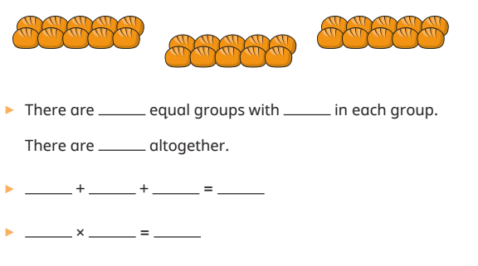  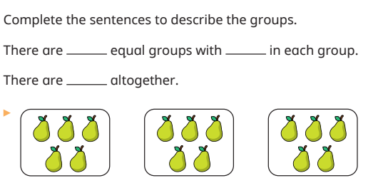  Equal groups  Children use repeated addition to help them solve this questions.  10 + 10 + 10 = 30  This is the same as 3 x 10 = 30  Children should be able to see there 3 equal groups with 5 pears in each group.  There are 15 pears altogether.  3 x 5 = 15  Arrays Part – whole model  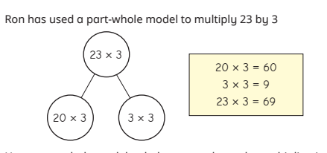  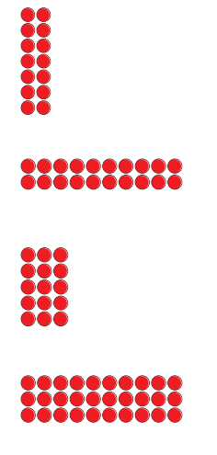  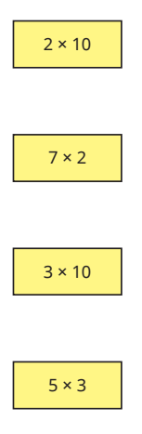  The 2-digit number is partitioned into tens and ones, both are multiplied by the 1-digit number and then the partial products are added to find the total product.  Children use arrays to help them group in order to be able to work out a multiplication number sentence.  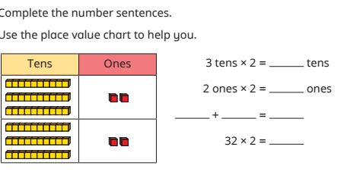  Dienes and counters (no exchange)  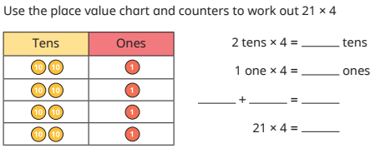  The 2-digit number is partitioned into tens and ones, both are multiplied by the 1-digit number and then the partial products are added to find the total product. This is explored through a progression of representations from base 10 to place value counters.  With exchange  This involves partitioning the 2-digit number into tens and ones, multiplying separately, then adding the partial products together. Children use the same representations as in the previous steps to provide familiarity and focus their attention on the new aspect of making an exchange. Use of the expanded method allows children to gain a deep understanding of the structure of the calculation before progressing to formal short multiplication in Year 4.  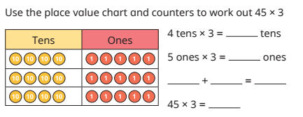

Division | 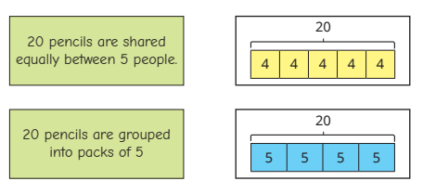  Sharing and grouping  A bar model is a particularly useful pictorial representation when sharing and grouping and can help children make sense of what the question is asking, as well as what the answer represents.  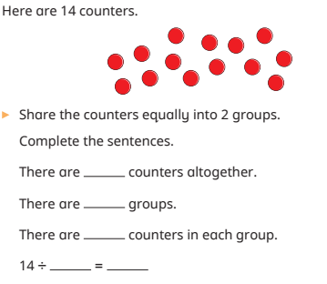  Counters (no exchange) Part – whole model (no exchange)  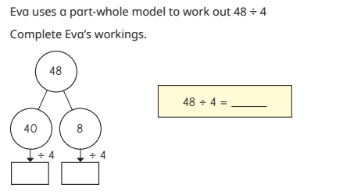  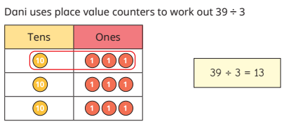  This step focuses on partitioning a number into tens and ones and sharing into equal groups, dividing numbers that do not involve exchanging or remainders. For example, 63 ÷ 3 can be partitioned into 60 and 3 and then shared into three equal groups: 60 ÷ 3 = 20 and 3 ÷ 3 = 1, therefore 63 ÷ 3 = 21

Counters (exchange) Part-whole model (exchange)
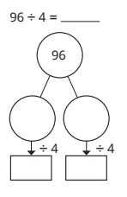
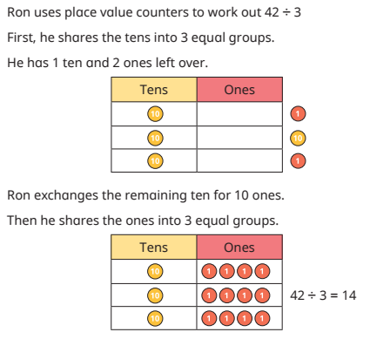
4
20
80
16
Children, using the part-whole model, exchange a 10. Which then allows the number to be divisible.

Counters with remainders

Step 1 Step 2
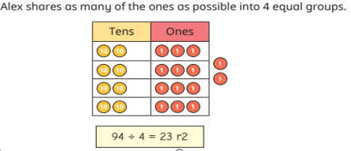
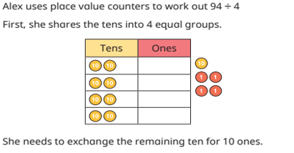
Children look at calculations that may involve exchanging between the tens and ones, and that have a remainder. This will be the first time children have encountered remainders

