Year 1 | Addition and Subtraction
- Read, write and interpret mathematical statements involving addition, subtraction and equals signs
- Represent and use number bonds and related subtraction facts within 20
- Add and subtract one digit and two digit numbers to 20, including 0
- Solve one step problems that involve addition and subtraction, using concrete objects and pictorial representations, and missing number problems such as 7 = ? - 9
- Children understand the effect of adding and subtracting zero. This establishes the relationship between the two operations.
- Understand that addition can be done in any order but subtraction cannot.
Addition  Children use and know their number facts.  Number bonds to 10 and 20 | 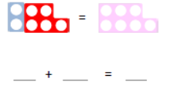  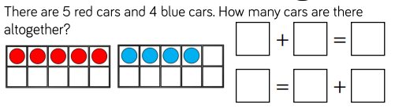  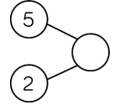  Part whole model Ten frame Numicom
Number line Number bonds Partitioning Counters

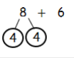
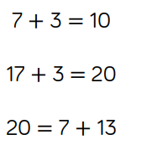
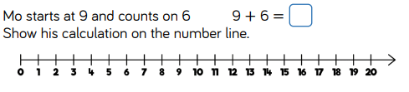

Subtraction  Children should be introduced to subtraction as counting back. Counting on is a progression from this and teachers should use vocabulary such as, ‘How many more? What is the difference between?’ | 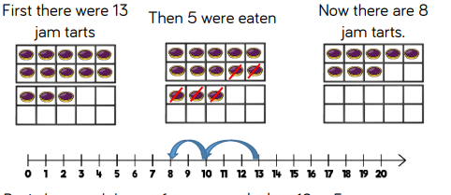  How many left? Pictorial Number line  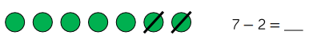  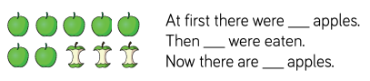  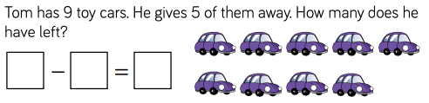
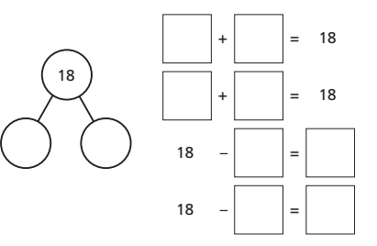
Part / Part / Whole
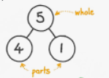
Children use related facts and the inverse to solve calculations.
5 – 4 = 1
1 = 5 – 4
4 = 5 – 1

Year 1 | Multiplication and Division
- Solve one– step problems involving multiplication and division, by calculating the answer using concrete objects, pictorial representations and arrays with the support of the teacher.
- Through grouping and sharing small quantities, pupils begin to understand: multiplication and division; doubling numbers and quantities; and finding simple fractions of objects, numbers and quantities.
- They make connections between arrays, number patterns and counting in twos, fives and tens.
Multiplication  Children count on in 2s, 5s and 10s. | Number grids to discuss patterns counting in 2s, 5s and 10s Use number lines to count in 2s, 5s and 10s  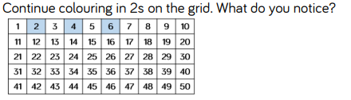  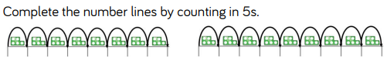    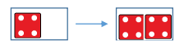  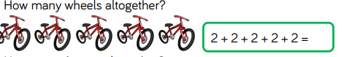  Adding equal groups Making doubles

Division  Children use concrete objects, pictorial representations and arrays with the support of the teacher | Sharing equally Making equal groups  

